# The suburbanisation of poverty in British cities, 2004 to 2015/16: extent, processes and nature

### Abstract

This paper extends previous analyses of the suburbanisation of poverty in Britain using data from Government Indices of Deprivation for 2004 to 2015/16. It tracks changes in relative centralisation and relative concentration of poverty for the 25 largest cities or urban areas, analysing change for poor and non-poor groups separately, and examining parallel changes in spatial segregation or unevenness. The paper confirms that poverty is suburbanising, at least in the larger cities, although poverty remains over-represented in inner locations in most cases. Suburbanisation is occurring through the absolute reduction in low income populations in inner locations and the growth non-poor groups, consistent with a process of displacement. Relative centralisation of poverty has fallen more strongly between 2004 and 2015/16 than relative concentration of poverty, as the outward shift of poorer groups leaves them still living in denser neighbourhoods on average. The paper also shows that spatial segregation (unevenness) declined over this period. It remains to be seen whether this last change is a long-term shift to less segregated urban forms or a transitional outcome before new forms of segregation emerge around suburban poverty concentrations.

### Acknowledgements

The research was supported by funding from the UK’s Economic and Social Research Council as part of the Applied Quantitative Methods Network (AQMeN) II project (ES/K006460/1). We benefitted from various conversations with AQMeN colleagues, notably Gwilym Pryce and Meng Le Zhang at the University of Sheffield. We are grateful to Paul Norman, Leeds University, for his collegiality in sharing data used in one stage of the analysis.

# The suburbanisation of poverty in British cities, 2004 to 2015/16: extent, processes and nature

## Introduction

For most cities in early-industrialising countries, suburbanisation initially occurred through the movement of more affluent groups to the suburbs, taking advantage of the expansion of public and private transport from the late nineteenth century onwards. As a result of this selective out-migration, low income groups tended to become over-represented in older inner urban locations with higher density housing close to the industrial core. Post-war reconstruction, in European welfare states in particular, led to some spatial redistribution of poverty to new social housing estates on the edge of the built-up areas. The general pattern, however, remained one of affluence further out where the environment was cleaner, and the neighbourhoods more socially ‘selective’. Poverty and urban deprivation became primarily ‘inner city’ problems (Robson 1988).

In recent decades, there have been signs in a number of countries of a gradual shift away from this situation, described as the ‘suburbanisation of poverty’; for the US, Kneebone and Berube (2013), Cooke (2010) and Cooke and Denton (2015); for Toronto in Canada, Hulchanski et al (2007); for Australia, Pawson et al (2015) and Randolph and Tice (2016); for England, Hunter (2014); and for the Netherlands, Hochstenbach and Musterd (2017). The primary driver of change has been the fundamental shifts in urban economies and their labour markets under globalisation (Smith 2002). More recently, the dismantling of social protection systems under neo-liberal regimes, including reductions in social housing, is further accelerating the change through the recommodification of housing stocks (Taylor-Gooby 2013; Musterd et al 2016). If these trends continue, the logical outcome will be, as Ehrenhalt (2012) neatly expressed it, an ‘urban inversion’ – cities with affluent and exclusive cores, where lower income groups have been driven out.

These shifts raise a number of issues. On the one hand, there are questions about whether we view the changes as processes of disruption and displacement for low income groups, during which valued communities are being destroyed, or whether they arise more through voluntary shifts which reflect positive (albeit constrained) choices (Smith 2002; van Gent 2013). With many former industrial cities marked by high levels of vacant and derelict land around the urban core, there is some scope for re-population without entailing the displacement of existing communities but the extensive literature on gentrification suggests that that is the exception rather than the rule. Relatedly, there are questions about the implications of suburbanisation for the future welfare of low income groups: whether moves to lower density, less central locations bring opportunities or costs, for example, in relation to access to employment, especially for those reliant on public transport (Hulchanski et al 2007; Pawson et al 2015); and whether these moves offer lower income households access to the better services of the suburbs such as higher quality schools, or a better environment with lower air pollution (reference removed for review), or strand them in locations where the provision of basic social services is lacking and civic organisations are weak (Cooke and Denton 2015). In some countries, at least, there are challenges in re-orienting anti-poverty policies and infrastructures designed around problems of denser inner-urban locations to new settings with very different contexts (Kneebone and Berube 2013).

More immediately, the challenge for researchers is to capture the scale and nature of the changes, the processes which underpin them, and the new urban forms which are emerging. Some important questions include: is poverty suburbanising in all cities, and to the same extent? Where in the urban areas is poverty moving to? How do we best capture the changes, given that we lack standard definitions of core and suburb, and that cities take an increasing variety of spatial forms? Additionally, is poverty in the inner cities being diluted through the in-migration of non-poor groups but largely without displacement, or is the increase in the non-poor population occurring at the expense of those in poverty? Finally, do the processes lead to a more even distribution of poverty and a reduction in segregation overall, or to new forms of segregation and the re-concentration of poverty in some suburban locations?

The aim of the paper is to analyse the extent and nature of the suburbanisation of poverty in the major cities of England and Scotland. First, we look at overall change for each city using measures of both centralisation and concentration to cope with problems of polycentricity and heterogeneous urban forms. Second, we examine changes in the numbers of poor and non-poor in different locations to assess whether any suburbanisation of poverty is merely a relative one, occurring through dilution of poverty in inner locations as these areas are re-populated, or an absolute one, suggesting displacement of lower income by higher income groups. Third, we examine the relationship between changes in decentralisation, deconcentration, and spatial segregation or unevenness – the extent to which poor and non-poor tend to live in the same neighbourhoods regardless of where in the city these are located.

## Background

### Drivers of poverty suburbanisation

Cities appear to be undergoing quite fundamental transformations in spatial organisation under the impact of a related set of economic, political and social processes: rising income and wealth inequalities, reflecting in part the impacts of globalisation and economic restructuring; parallel political shifts in welfare and housing policies under neo-liberal political regimes; and social changes of deferred family formation as well as cultural preferences for urban living (Atkinson 2014; Musterd et al 2016; Peck 2014). Rising inequality feeds through into the urban system, both in an increased desire for spatial distance to reflect socio-economic distance (Musterd et al 2016), but also because of the increasing ability of higher income groups to outbid lower income ones in the housing market for desired neighbourhoods (Randolph and Tice 2016; Hulchanski et al 2007). Related to this is the continued restructuring of urban economies and labour markets under the dual influences of technological change and globalisation. Urban labour markets have seen a loss of employment opportunities for skilled manual workers, particularly in more central urban locations, alongside the growth in professional and other white collar occupations. Whether these changes are described as polarisation, or professionalisation (Sassen 1991; Hamnett 1998), there is a relative decline in the market position of lower income groups.

While structural economic shifts help explain the rising opportunity for higher income groups to move into central urban areas, other factors are needed to explain why they choose to take this up. Cultural explanations provide part of the answer, although they do not stand apart from economic factors. Urban living has been promoted by those interested in the recommodification and redevelopment of inner urban locations (Urban Task Force 1999; Smith 2002). The latter includes both private interests but also the increasingly ‘entrepreneurial’ urban governments seeking to maintain or re-build the economic base of their cities (Harvey 1989; Peck 2014). Other factors include the demographic shift of deferred fertility and hence the rising number of young adults in childless households (Castles 2003), for whom inner urban locations offer many advantages.

Politics and policy are implicated at a range of levels. Rising inequality reflects in part changes in labour market regulation and social protection measures (Atkinson 2014). More directly, urban policy has played a significant role in facilitating – and occasionally limiting – processes of gentrification (Bailey and Robertson 1997; Smith 2002). In the 1980s and 1990s, efforts to stem urban population loss and drive re-investment in declining urban areas were promoted by governments as interventions that would benefit existing (and especially poorer) residents by increasing economic opportunities and promoting more mixed communities (Urban Task Force 1999; Schoon 2001). Others criticised these efforts as state-led gentrification or neo-liberal urbanism, designed to displace working class communities for the pursuit of capital and middle class interests (Smith 2002; Hochstenbach and Musterd 2016). In part, judgements about the impact of these programmes hinge on the eventual outcome: whether it is the development of stable mixed communities, still providing access to housing for low-income groups; or transitory mixing, before the eventual displacement of low-income groups, leading eventually to exclusive upper- or middle-class occupation of the urban cores. Displacement here is understood in the broad sense of both direct replacement on poor housholds by non-poor, but also indirect effects where poor households lose the ability to access a neighbourhood due to rising housing costs (Marcuse 1985).

Wider welfare and housing policies play a role in the pace and form of change (Musterd and Ostendorf 1998). Many countries have seen the progressive erosion in welfare benefit levels, with an acceleration since the Global Financial Crisis of 2007/8, which has been used to legitimise the rolling back of the state (Taylor-Gooby 2013). Housing policy decisions are especially important, with investment in de-commodified social housing limitting the scope for market-led restructuring (Bailey and Robertson 1997), whereas efforts to recommodify housing have the opposite effect (Forrest and Hirayama, 2015). In the UK, key policy changes from the 1980s and 1990s have been towards re-commodification, notably through the sale of social housing to tenants under the Right-to-Buy, and the encouragement of investment in private renting through the deregulation of tenancies and of lending institutions (Malpass 2005; Kemp 2010).

Since 2007/8, the UK has seen successive moves to reduce entitlements to welfare and housing subsidies for tenants, particularly in the newly-expanded private rented sector. There are tighter limits on the rent levels which can be covered by Housing Benefits, caps on the total amount of benefits which a household can receive in one year including housing subsidies, and reduced entitlements for younger adults to housing subsidies (DWP 2014). These changes are explicitly intended to make the recipient households more ‘cost-conscious’ and hence to drive changes in consumption patterns, as well as increasing incentives to find paid work or extend working hours. Early evaluations of the impact of these changes have shown particular pressures in the highest cost locations such as central London driving outward moves of households (DWP 2014).

At the other end of the suburbanisation process, there is an important literature which has examined the growing differentiation within suburban locations and emergence of decline with a particular sub-group of these places. Terms may vary but the broad details are clear: these are older inner suburbs, often from the post-war years where housing is becoming obsolescent compared with newer suburban developments, but reinvestment is more sporadic and uncoordinated than in the urban core. Many of these locations suffer a combination of social problems (high unemployment and crime, for example) and poor infrastructure and public services (Randolph and Freestone 2012; Hanlon 2010).

While the broad drivers of the suburbanisation of poverty are clear, we would of course expect to see some degree of variation between places, as processes are historically and institutionally contingent as the evolutionary economics literature highlights (Boschma and Frenken 2006). Cooke and Denton (2015) show variations in patterns of poverty decentralisation between the major US metropolitan areas. In a closely-related study of spatial segregation in European cities, Musterd et al (2016) show variation in both pace and direction of change in recent years, and how this relates to a number of structural characteristics including the strength of ties to the global economy and the nature of the local welfare regime.

In the UK context, we would expect various factors to influence the pace of change. First there is city size, positively related both to agglomeration benefits and disbenefits, but also to the physical separation and hence commuting costs that go with suburban residence. We would expect pressures to be greater in the larger conurbations, with London a clear outlier in the UK context. Second, there is the state of the local economy which translates into both wage levels and housing costs, and hence affordability for lower income households. Affordability indices for England show wide variations between cities with particular problems again in London which contains seven of the ten local authorities with the least affordable housing in 2016 (ONS 2017). It is in the higher cost locations that the cuts and caps in Housing Benefits will also have most impact (DWP 2014).

The relationship between suburbanisation and spatial segregation or unevenness may not be simple. While, in general, we might expect that cities will ultimately become more segregated as poverty suburbanises – Ehrenhalt’s ‘urban inversion’ thesis – it is possible that the processes bring at least a temporary reduction in segregation as inner urban neighbourhoods become more mixed during a transitional stage. Bailey et al (2016) show exactly this kind of change at work in Amsterdam during the early 2000s, for example. It is also possible in theory for decentralisation or suburbanisation to be associated with a dispersal of poverty and hence a longer-term reduction in segregation rather than new concentrations emerging in suburban locations although, in practice, this seems highly unlikely given that spatial inequalities have been almost the defining feature of modern cities.

### Conceptual and measurement challenges

The term ‘suburbanisation’ implies movement to areas with a particular built form and density, but it also carries important connotations of class and lifestyle, most notably of safety and conformity, in contrast to the ‘dangerous’ or ‘degenerate’ inner cities (Kneebone and Berube 2013). Suburbanisation therefore carries suggestions not just of loss or displacement, but also new opportunity. In most locations, however, we lack clear definitions of the ‘suburb’. In the UK, Hunter (2014) uses a combination of housing type (low proportions of flats or terraced housing, to try to exclude inner urban locations) and density (above a minimum threshold, to exclude rural areas) as the basis of his analysis. Such an approach is open to a number of challenges over the selection of cut-off points. Others have focussed on density alone (Cooke and Denton 2015, for example), reducing suburbanisation to deconcentration.

An alternative is to focus centrality or distance from the city centre. This places a greater focus on physical location and, in particular, distance from and accessibility to the urban core. It foregrounds to a greater extent concerns about loss of access to the centre and the opportunities which that might offer, most notably for employment. Identification of the central location from which to measure distance remains an issue although empirical testing in relation to measures of decentralisation suggests it has minimal impact (Kavanagh et al 2016). In the traditional monocentric city, there is a strong relationship between centrality and density, so the choice of measure may be relatively unimportant but the growing polycentricity of many urban areas means that movement away from the main centre does not always represent movement to more suburban settings. Capturing suburbanisation through a combination of decentralisation and deconcentration measures is therefore important, as is an understanding of the relationship between centrality and density for each city.

A related measurement issue is how we define our cities. If the boundary is drawn too tightly, it will exclude many areas which function as suburbs of the central city. In the UK context at least, administrative boundaries are highly problematic in this regard due to the very variable basis on which these have emerged, with significant under-bounding in many cases; the contrast between the city authorities for Leeds and Manchester is particularly stark. Physical built-up areas are little better, particularly in contexts like the UK, where planning policies have sought to contain outward sprawl through Green Belts, pushing urban overspill into physically-separated but functionally-connected settlements. City-regions or travel-to-work areas (TTWAs) offer a better basis for analysis since they are constructed from commuting flow data that reflect functional urban/regional relationships. However, the inclusion of surrounding settlements again means that the relationships between centrality and density may be more complex. Indeed, some TTWAs in the UK are composed of two or more urban centres of similar size, forming polycentric urban regions. As before, the solution is to pay greater attention to deconcentration in more polycentric contexts.

A last issue concerns how it is that any decentralisation or deconcentration of poverty comes about. If there is increasing housing supply in inner or denser areas which is taken up by non-poor groups, decentralisation and deconcentration of poverty can occur without any reduction in the absolute numbers in poverty in these locations. In such cases, suburbanisation is a relative process as poverty is ‘diluted’ in inner or denser neighbourhoods without displacement. High levels of vacant and derelict land in many former industrial centres make this a real possibility. Alternatively, change can occur through absolute suburbanisation if inner or denser areas see reductions in the number of people in poverty able to live there. To capture these processes, we need to move beyond global measures of the distribution of one group relative to another, and look at the distribution of each group separately.

## Data and methods

### Poverty by neighbourhood

In the UK, each of the four national governments publishes area deprivation measures for small geographic areas through their official Indices of Multiple Deprivation (IMD). The IMDs have been constructed on a consistent basis since 2004 by compiling data from a wide range of administrative sources (for details, see Noble et al, 2006). They are widely used by government in policy analyses and resource allocation decisions, as well as by many researchers. The English IMDs (EIMDs) were updated in 2004, 2007, 2010 and 2015, while the Scottish IMDs (SIMD) were updated in 2004, 2006, 2009, 2012 and 2016.

The spatial units for the EIMD are called Lower Super Output Areas (LSOAs), designed to have populations between 1000 and 2000. Relatively minor adjustments were made to LSOA boundaries for the 2015 index to reflect population changes, with a small minority of LSOAs split or merged (and just 0.5 per cent seeing more complex changes). We re-apportion data for the earlier years to the 2015 boundaries based on the number of postcodes found in each area.[1]

The analogous units for the SIMD are termed Datazones (DZ) with considerably smaller populations, between 500 and 1000. Boundaries were comprehensively updated in 2016 to reflect population changes. Data for earlier years can be re-aggregated to the new boundaries on the same basis as in England although the more complex boundary changes mean this leads to a lower quality fit. For measures of centralisation or concentration, this has minimal impact so results for these measures are all presented using current boundaries. For measures of spatial segregation, reaggregation in Scotland leads to significant error, biasing the measures down and rendering comparisons between data for old and new boundaries problematic. When looking at spatial segregation for the two Scottish cities, we therefore base our analysis on the original (2001) Datazone boundaries, making 2012 the latest available time point.

As part of the overall measure of area deprivation, both IMDs construct a measure of Income Deprivation and it is this which forms the basis for our analysis. This is a low-income poverty measure, capturing the proportion of people living in households in receipt of a welfare benefit or tax credit by virtue of their low-income. Importantly for our work, this measure covers not just the unemployed or those unable to work through long-term sickness or disability, as well as the retired, but also people in employment who are still on low income. The UK government’s analysis shows that more than half of people in low-income poverty in the UK live in households where there is at least one person in paid work (DWP 2017); this uses a household survey measure, defining low income poverty as below 60 per cent of the median (equivalised) household income. There are some minor differences between EIMD and SIMD Income Deprivation measures although they are quite comparable (for details, see Noble et al 2006 and Payne and Abel, 2012). Both measures very largely exclude full-time students as they are not eligible for the majority of the benefits on which the indices are based.

The detailed construction of both measures has changed over time as the welfare benefits and tax credit systems have evolved. These measures should not therefore be used to draw conclusions about how the absolute level of poverty in a neighbourhood or city has changed over time. In our analyses, we avoid this problem by focussing on the relative distribution of poverty across the cities at each time point. In effect, the changes in definition mean that we use a slightly different threshold for our poverty measure at each time point but there is little reason to expect this small variation will be strongly related to the geography of poverty within each city.[2]

### Categorisation of urban regions

In this paper, cities or urban regions are defined on the basis of official TTWAs, as updated in 2016 to reflect commuting patterns in the 2011 Census (ONS 2015). In general, residential moves within TTWAs should represent moves without a change in labour market area. For the central point of the city, we take a mid-point between the city hall and the central railway station(s) for the largest settlement. Earlier analyses have shown that using alternative cut-offs for city limits or varying the definition of the central point has minimal impacts on measures of relative centralisation, at least for the relatively monocentric Scottish cities (Kavanagh et al 2016).

We have used the largest 25 TTWAs by population as our set of cities, avoiding any other selection criteria.[3] Table 1 shows their populations in 2009/10 and poverty rates (Income Deprivation) for the first and last year. The latter are not to indicate change in poverty levels over time given the limitations discussed above but to show that the Income Deprivation measures offer a relatively consistent threshold over time; the changes over time within each city are much smaller than the differences between cities. Income Deprivation ranges from less than 10 per cent in some of the smaller cities of the south of England to 20 per cent or more for the larger cities.

We have chosen not to limit our selection of urban areas to only those which conform to a monocentric form of development in order to examine change across the spectrum of urban contexts which exist in Britain today. Our set is intentionally mixed, and we have therefore grouped them based on a combination of size (population) and form. For the latter, we look at the correlation between density of neighbourhoods and distance from the city centre. A high correlation implies a more monocentric form as density declines more evenly with distance. This yields three groups. First we have a group comprising the 11 largest cities. All are relatively monocentric in form with a recognisable core city. In some cases, the correlations between centrality and density are relatively low (0.3 to 0.4), reflecting a combination of population thinning in inner areas and the capture of significant secondary settlements within the TTWA boundary; Manchester, Glasgow and Newcastle are the main examples here. Second we have smaller cities which are relatively monocentric in form; correlations between centrality and density are above 0.3. Third we have smaller TTWAs with more complex, polycentric urban forms where the main settlement is not as obviously dominant, as sometimes indicated in the TTWA names; correlations of centrality and density are below 0.3. This group comprises Warrington & Wigan, Wolverhampton & Walsall, and Guildford & Aldershot, as well as Luton, Southend and Cambridge.

[Table 1 about here]

### Measurement of centralisation, concentration and segregation

We calculate separate measures of centralisation and concentration to capture the relative spatial distribution of poor and non-poor groups in each city at each time point. The Relative Centralisation Index (RCI) measures the extent to which one group tends to live closer to (or further away from) the city centre, relative to another group (Massey and Denton 1988). This ranges from ‘1’ where the reference group (here, the poor or Income Deprived) occupies all the sites around the centre to ‘-1’ where they occupy all the sites at the city’s edge. It is calculated as:

$$RCI= \sum_{k=2}^{N}{(X_{k-1}Y_{k}- X_{k}Y_{k-1})}$$

Ordering the N neighbourhoods of the city by centrality or distance from the centre, Xk is the cumulative proportion of group X in neighbourhoods 1 to k. Xk is for the reference category (in this paper, the poor or Income Deprived) and Yk is the remainder (here, the non-poor).

The Relative Density Index (RDI) measures concentration or the extent to which one group tends to live in more or less densely occupied locations, relative to another. It is calculated on exactly the same basis as RCI only ordering neighbourhoods by density (descending) rather than centrality, and it shares the same -1 to +1 scale. Density is calculated simply as the ratio of the population to the gross area of the neighbourhood unit with no attempt to allow for land given over to infrastructure, large open spaces or open water.

We also calculate a simple measure of spatial segregation or unevenness, using the familiar Index of Dissimilarity (D). This captures the extent to which each neighbourhood contains a similar share of the city’s poor and non-poor groups (Duncan and Duncan 1955). This ranges from ‘0’ (completely even distribution) to ‘1’ (complete segregation):



Summing across the N neighbourhoods of the city, *xk* is the number of people in neighbourhood *k* who are poor and *X* the total number poor in the city, with *yk* and *Y* the corresponding figures for non-poor.

Table 1 also reports a housing affordability measure for the core authority in each TTWA to give an indication of pressures in the housing system, particularly in central city locations; for London, we use the combined Greater London authorities. Housing affordability is the ratio of lower quartile house price to lower quartile gross annual (residence-based) earnings (ONS 2017). The measure is not available for the two Scottish authorities. Housing affordability worsens over time in almost every case, suggesting that the impacts of the recession following the Global Financial Crisis on house prices were less than their impacts on wages at the lower end of the market. Of the large cities, London clearly faces exceptional pressures, but affordability problems are also evident in a number of the smaller southern cities.

## Results

### (i) Distribution of poverty

Table 2 provides all three measures of the spatial distribution of poor and non-poor groups (RCI, RDI and D) for each city in 2004 and 2015/16, as well as change over time. As Table 2 shows, poverty is relatively centralised in almost all of our cities as expected although there are exceptions. In four cases, RCI is zero or negative in one or both years. Three of these cities are in the group of smaller polycentric TTWAs, with Cambridge showing the strongest decentralisation. Two factors are at work in that case: polycentricity within the TTWA due to the inclusion of a London overspill New Town (Harlow) far from the central city; and the presence of a well-preserved and high-demand historic core with limited housing opportunities for lower income groups. Housing affordability is particularly poor in the Cambridge local authority which covers the main city (Table 1). The other two in this group have strongly polycentric forms, as indicated by the names, suggesting that centrality is a less useful measure in these cases. The fourth exception is Edinburgh, a smaller monocentric city which is similar to Cambridge in having a well-preserved historic core where post-war redevelopment for social housing was heavily restricted and where demand for housing is high, and has been for some time. In a further three cities, RCI falls below 0.05, indicating low relative centralisation of poverty. At the other end of the spectrum, the highest levels of RCI are found predominantly in the large monocentric cities.

Table 2 also shows that poverty is relatively concentrated. Indeed, concentration is a more consistent feature across the set of cities; RDI is above 0.08 in every city and at every time point, indicating that Income Deprived groups tend to live in higher density neighbourhoods. For the largest cities in 2004, poverty was more strongly related to centrality than to density; RCI was greater than RDI in all but three of these eleven cases – London, Manchester and Nottingham were the exceptions. In the smaller cities, the opposite was true with only three cases in this group where RCI was greater than RDI in that initial year (Southampton, Coventry and Wolverhampton & Walsall).

[Table 2 about here]

A finer-grained picture of the distribution of poverty at the start of our study period (2004) is shown in Figure 1. This plots the share of the poor within a city living in each decile of neighbourhoods, ordered by centrality (distance from the centre) and by density (descending). Equal population deciles are used so that comparisons between cities are more easily made since cities vary in spatial extent and in the range of densities present. In these plots, a value of ‘0.1’ (i.e. 10 per cent) therefore indicates that a decile has the same share of those in poverty as it does of the total population. For the larger cities, the share of poverty declines with both distance and density as expected, although the relationship of poverty with density is generally the more consistent than that with centrality. In every case, poverty is over-represented in the most central and most dense deciles, but under-represented in (almost) all of the less central or less dense half of the cities. There are local variations apparent, with more pronounced centralisation in some cases (notably Birmingham, Leicester and Leeds). In London, the most central decile already showed a share of poverty in 2004 which was only marginally above the average for the TTWA although poverty levels were higher in the next four deciles.

In most of the smaller monocentric cities, the patterns were similar but in three cases – Edinburgh, Southampton and Oxford – the peak concentration of poverty by distance was not in the first two deciles. In the smaller polycentric cities, the distributions by centrality showed two or more peaks rather than a steady decline in poverty share with distance, whereas those by density showed more continuous downward trends. The former indicate concentrations in secondary centres and again this underlines the problem of using centralisation measures in these contexts.

[Figure 1 about here]

### (ii) Decentralisation and deconcentration

Changes in RCI and RDI over time give a global picture of suburbanisation in the 25 cities (Table 2 and Figure 2). Poverty became less centralised and less concentrated in almost every case. Change on each measure is broadly correlated (R=0.50) but the pace of decentralisation is clearly greater than of deconcentration. Comparing 2004 with 2015/16, the average reductions were 0.05 for RCI compared with 0.02 for RDI respectively. The cities with the greatest relative centralisation and concentration of poverty in 2004 saw the largest reductions on each measure. By 2015/16, the degree of concentration was greater than of centralisation in 20 of the 25 cities, including six of the largest eleven.

The pace of change was greatest in the larger cities, particularly London which saw the biggest reductions in relative concentration and the second biggest reduction in relative centralisation. The changes fit with our expectations about the role of city size discussed above. It is also in London that the constraints on welfare benefits, particularly housing benefit, will have most impact due to high house and rental prices (Lupton 2011; DWP 2014). At the same time, it is clear that while low income groups are being pushed out of the more central areas, they are not moving to areas with much lower densities as relative concentration is not falling at the same rate. Rather they are moving to less central but still relatively dense neighbourhoods. For the group of larger cities, decentralisation is greater than deconcentration in every case.

With the smaller monocentric cities, there is a more mixed picture. Three cases (Edinburgh, Southampton and Oxford) show changes similar to those in the larger cities, with falls on both measures, particularly centralisation. Edinburgh is particularly striking since it had one of the lowest levels of centralisation to start with. The other two both have relatively poor affordability. Other smaller cities show only limited change on either measure, with one (Crawley) showing a modest increase in the centralisation of poverty while another (Medway) shows a modest increase in concentration.

The polycentric cities showed the least centralisation to start with and they show little change on this measure, though the concept of ‘centralisation’ is inherently problematic in these cases. Levels of concentration were similar to the other cities at the outset and there is little change in most cases although two cases (Luton and Cambridge) see significant reductions. In Luton, a city with a stronger industrial base, the concentration of poverty was one of the highest of any of the set of 25 cities at the outset and it remained well above average in 2015/16.

[Figure 2 about here]

### (iii) Relative versus absolute changes

We turn now to the question of whether suburbanisation occurs through relative or absolute changes in the distribution of those in poverty. We do not measure changes in the absolute number of people who are poor or not-poor over time due to the alterations to the Income Deprivation measure discussed above. Instead, we look at how the share of the poor and non-poor within each city shift over time for each decile of neighbourhoods. Figure 3 shows changes for the share poor and non-poor by deciles of distance from centre (as defined in 2004) while Figure 4 shows the equivalent by density. Deciles are defined in 2004 so the shifts show the effects of both new housing supply and changes in the occupation of the existing stock. For each group (poor or non-poor), the changes across the deciles in a city sum to zero since a gain by one decile comes at the expense of others.

London is again an exceptional case in the UK context. It shows the most wholesale change and a pattern which is rather different to the other cities, with the most central five deciles all showing a reduction in their share of the poor and a gain in their share of the non-poor. There is a similar picture in relation to density with only the most dense decile not showing a rise in the non-poor group. As noted above, this city showed the second greatest drop in RCI and the greatest drop in RDI. Here we can clearly see absolute suburbanisation underway, and it is affecting the most central half of the city. Between them, the inner five deciles saw their share of the TTWA’s poor decline by 5.3 per cent. With around 1.22 million poor in London (taking the population and poverty rates from Table 1), this equates to a reduction of approximately 65,000 poor people in an 11 year period within this half of the city.

[Figures 3 and 4 about here]

In the other larger cities, the changes are less extensive, but nevertheless there is clear evidence of absolute suburbanisation. In terms of centrality, the changes mainly occur in the most central one or two deciles. These were the locations with the greatest over-representation of the poor population in 2004 (see Figure 1 above). It is in these places that the share of the city’s poor declines most markedly while the share of the non-poor rises simultaneously. Liverpool is an exception here, as the rise in non-poor groups in the central decile is accompanied by only minimal decline in the share of poor groups living there, suggesting only relative suburbanisation in this case. Liverpool local authority has the most affordable housing of any of the cities in our study (Table 1) so the impacts of welfare reform are likely to be least significant here. In other cases, the absolute scale of the impacts is again substantial: for Manchester, we can estimate 13,000 fewer poor living in the inner two deciles, 9000 fewer in Birmingham and 6000 fewer in Glasgow. Across the eleven larger cities, the number of poor in the inner two deciles has declined by about 80,000.

In relation to density (Figure 4), it is less clear that the process underway involves absolute displacement. Rather the picture is of a general drift of both groups towards less densely occupied deciles. In the densest decile, there is a sharper fall in the share of poor in most cases, but much less sign of an increasing share of non-poor in the same locations. A couple of cities see some replacement of poor by non-poor groups in the most dense areas (Leicester or Nottingham, for example) but other cities – such as Glasgow - see a reduction in the proportion of poor people without simultaneous in-movement of non-poor.

With the smaller monocentric cities, the picture is even more varied. The cities where poverty became more decentralised and deconcentrated - Edinburgh, Southampton and Oxford - show a process of decentralisation which is similar to the larger cities. The change in Edinburgh appears especially widespread, with the inner five deciles all showing a declining share of the poor, equivalent to a reduction of around 4000. Here, there is evidence of absolute suburbanisation as the most central deciles lose their share of the poor population while gaining share of the non-poor, although the changes are not as sharply defined as with the large cities. In terms of concentration, both poor and non-poor are moving towards less dense neighbourhoods in these cities so it is the faster pace of out-movement by the poor which produces relative deconcentration. In the other cities in this group, the patterns of change are much more similar for poor and non-poor which is why relative centralisation and concentration were little changed in these cases.

For the polycentric group, only Luton and Cambridge showed both decentralisation and deconcentration. Both show evidence of a shift from poor to non-poor in the most central decile and, in Luton’s case, also the densest decile, but patterns are more varied in other parts of these cities. For the four remaining polycentric regions, however, the main change is the deconcentration of the population, poor and non-poor, rather than the direct substitution of one for another so again it is difficult to see this as a process of absolute suburbanisation.

### (iv) Suburbanisation and spatial segregation

Up to now, the paper has focussed on suburbanisation but this has served to mask an important shift common to almost all of our cities: the reduction in levels of spatial segregation or unevenness (last three columns of Table 2). Spatial segregation is a ubiquitous feature of modern and post-modern cities, and one which is frequently seen as problematic by governments (Livingston et al 2013). Musterd et al (2016) argue that segregation has been rising in European cities, at least in their group of capital cities. Direct comparisons of levels of segregation are problematic since they depend so much on the set of neighbourhood units used to divide up each city but it is clear that, for our group of British cities at least, segregation has been declining in this period. D fell from an average of .36 to .32 with mean falls similar for the three groups of cities. If we examine the measure across all the intervening years (not shown), we see a steady and continuous decline in almost every case, indicating this change is not merely noise.

In general, greater falls were seen in cities which had higher starting levels of segregation. The larger cities had slightly more segregation in 2004 and almost all showed substantial reductions by 2015/16 (2012 for the two Scottish cities). Leeds, and to a lesser extent Sheffield, appear slightly different with the former having the highest level of segregation in 2004 and one of the lower reductions. London had a lower starting point but the second largest reduction in segregation (from .34 to .28, down .06), again reflecting the scale of change underway there. For the smaller monocentric cities, Edinburgh had the highest initial segregation and the greatest fall. Reductions in segregation correlate with changes in centralisation and concentration (0.40 and 0.60 respectively).

This analysis puts the processes of suburbanisation is a rather different light. On the basis of these figures, suburbanisation could be portrayed as a shift to a more balanced urban form, moving from an over-concentration of poorer households in inner areas to a more even distribution across the cities, offering a route to the kinds of social mix advocated in many urban policy statements. Of course, the long-term impacts of suburbanisation remain to be seen. It is possible that the desegregation witnessed here is a temporary phenomenon as inner areas transition from over-representation of poorer groups to over-representation of non-poor, while new concentrations of poverty emerge in suburban locations.

The analysis in the previous sections suggests that quite different patterns of change are underway in the most central deciles of the cities, particularly in the larger cities (Figures 3 and 4 above). A related question is therefore whether the reduction in D is largely, or indeed, wholly attributable to changes in those locations. The answer may give some clues as to the likely longer term outcomes. The Dissimilarity Index, D, has a useful property here, because the score for a city is constructed by summing the contribution of each neighbourhood within it. We can therefore decompose the change in D into: that attributable to the most central two deciles; and that for outer eight. In Table 3, we do this for the eleven larger cities where the processes of suburbanisation are most evident. For ease of comparison, we show the decline in D for the outer eight deciles multiplied by 0.25, so that the rate of change there can be compared directly with the rate for the inner two deciles.

For most of the larger cities, the decline in segregation is (proportionately) faster in the inner two deciles than the rest of the city but it is still falling in both locations. At least at this stage in the process, the increasing share of poverty accounted for by outer areas is not associated with rising levels of segregation there. The poor may be constrained to the denser outer areas by the need to access cheaper housing, as noted above, but this has not meant movement in to a small number of areas with existing high concentrations of poverty. Rather segregation is falling because areas which previously had an under-representation of poverty are now becoming home to a larger share of poor households.

[Table 3 about here]

## Conclusions and discussion

This paper makes an important contribution to the literature on the suburbanisation of poverty, providing original empirical analyses of change in the spatial distribution of poverty in the 25 largest cities and urban areas in England and Scotland over the period 2004 to 2015/16. Complementary measures of decentralisation and deconcentration were used to overcome the problems caused by polycentric urban forms in particular. The paper also examines the changes for poor and non-poor separately to explore whether suburbanisation is a relative process resulting from the dilution of poverty in inner areas or an absolute process involving replacement of one by another. Lastly it casts light on the possible longer term consequences by examining the changes in levels of spatial segregation which have accompanied this phase of suburbanisation.

The results show that the suburbanisation of poverty is underway in British cities, with poverty becoming both less centralised and less concentrated over time in almost every case. Change was fastest in London as theory predicted. It is a unique city in the UK in terms of its scale and housing market pressures, and it is here that the impacts of welfare reform were expected to be greatest. Significant changes are also underway in many other cities, particularly the larger ones. At least in the larger cities, the process can be clearly described as one of absolute suburbanisation with inner areas losing share of the poor while simultaneously increasing their share of non-poor in almost every case. In London, change is occurring across a large swathe of the more central half of the city. In the other large cities, the changes up to now have been limited to the most central two or perhaps three deciles.

At the same time, these shifts are accompanied by significant and unexpected reductions in spatial segregation or unevenness. These changes potentially cast the processes of suburbanisation of poverty in a rather different light, as a shift away from the historic legacy of urban divisions arising from industrialisation. They contrast quite strikingly with some recent studies which have found rising levels of segregation in many European cities (Musterd et al 2016) and they certainly warrant further investigation. Of course, the reductions might be only temporary – a transitional phase on the way to establishing new forms of division as implied by the ‘urban inversion’ thesis. We do show however that, in this period, the reductions are occurring not just in the centres of the large cities where the over-representation of poorer groups is declining, but also in the outer areas where proportions poor are rising. Of course, if rising levels of poverty in some suburban locations prompt a reaction from more affluent groups, further rounds of adjustment may follow through the class-based equivalent of ‘white flight’. For the moment, however, we do not see such processes underway.

This paper also shows the wide variations between cities. City size emerges as an important factor as theory suggested. Further work could focus on explaining more of the variation between cities, both in their starting points as well as in the direction of change, following Musterd et al’s (2016) approach to explaining changes in segregation. Beyond city size, obvious factors to take into account would be housing market pressures or affordability, a particular concern in London, and the level of decommodification through social housing provision. Such work could point the way towards policy interventions to re-shape outcomes. The paper also shows the value of viewing suburbanisation through both decentralisation and deconcentration measures, particularly in the context of the more polycentric urban forms which exist in some British TTWAs. In these cases, there is often no clear process of decentralisation, while deconcentration is a more relatively process – the result of both poor and non-poor groups moving towards less densely-occupied areas, albeit that the poor shift slightly faster.

One particular strength of the analysis here is the use of a measure of low-income poverty which is constructed from linked administrative data, giving small area measures of the numbers poor at regular time intervals. The Income Deprivation measure captures people in households reliant on out-of-work benefits as well as those in working households but still on a low income. Changes in the welfare system over time mean that we are effectively using a threshold to identify poverty which moves up and down but only to a very limited extent, and we work around the problems this might create by focussing not on absolute change but on the relative shift of groups, poor and non-poor, between the set of neighbourhoods which make up each city. There is some potential for the changes in the Income Deprivation measure to have impacts which are spatially uneven and which could therefore distort the picture of spatial change but we do not believe this to be in any way significant.

One major issue in the debates about suburbanisation is understanding the processes by which suburbanisation occurs. With the current data, we cannot show that there is a process of direct displacement here, with poor households pushed out by rising housing costs, and being replaced by higher income groups. It is possible that reductions in low income groups in inner city locations are due to faster rates of movement out of poverty by those in inner areas, or that they arise from voluntary outward movements as individuals exercise positive choices to seek alternative neighbourhoods. However, the timing of the changes, coinciding with sharp cuts in welfare and housing subsidies for the poor and worsening housing affordability strongly suggest that displacement is the key underlying process.

Beyond the question of processes, we also need to understand the consequences of these changes, particularly for social welfare. There are questions about the subjective experience of suburbanisation, and the extent to which the displacements entailed are experienced as significant losses of desired communities or attachments. There are also important questions about the welfare and opportunities for low income households in the locations where their concentrations are increasing. There are potentially complex trade-offs here, with welfare gains - such as air quality or natural environment and green space - as well as losses - such as public transport services or access to employment opportunities. Nevertheless, documenting the scale and nature of the changes, and the processes which underpin them – the contribution of this paper – remains a valuable first step.

## References

Atkinson, A. B. (2014), After Piketty?, *British Journal of Sociology* 65 (4): 619-38.

Bailey, N. and Robertson, D. (1997) Housing renewal, urban policy and gentrification, *Urban studies* 34 (4): 561-78.

Bailey, N., van Gent, W., and Musterd, S. (2017) Re-making urban segregation: processes of income sorting and neighbourhood change, *Population, Space and Place 23(3)*.

Boschma, R. A. and Frenken, K. (2006) Why is economic geography not an evolutionary science? Towards an evolutionary economic geography, *Journal of Economic Geography 6* (3): 273-302.

Castles, F. G. (2003), The world turned upside down: below replacement fertility, changing preferences and family-friendly public policy in 21 OECD countries, *Journal of European Social Policy 13* (3): 209-27.

Cooke, T. J. (2010) Residential mobility of the poor and the growth of poverty in inner-ring suburbs, *Urban geography* 31 (2): 179-93.

Cooke, T. J. and Denton, C. (2015) The suburbanization of poverty? An alternative perspective, *Urban Geography* 36 (2): 300-13.

Department for Work and Pensions (DWP) (2014) *The impact of recent reforms to Local Housing Allowances: summary of key findings. Research Report No. 874.* London: DWP.

Department for Work and Pensions (DWP) (2017) *Households below average incomes (HBAI) quality and methodology report 2015/16.* London: DWP.

Duncan, O. and Duncan, B. (1955) A methodological analysis of segregation indexes, *American Sociological Review* 20: 210-7.

Ehrenhalt, A. (2012) *The great inversion and the future of the American city.* New York: Knopf.

Forrest, R. and Hirayama, Y. (2015) The financialisation of the social project: embedded liberalism, neoliberalism and home ownership, *Urban Studies* 52 (2): 233-44.

Hamnett, C. (1998) Social polarisation, economic restructuring and welfare state regimes, in Musterd, S. & Ostendorf, W. (eds) *Urban segregation and the welfare state: inequality and exclusion in Western cities, 15-27.* London: Routledge.

Hochstenbach, C. and Musterd, S. (2017) Gentrification and the suburbanization of poverty: changing urban geographies through boom and bust periods: *Urban Geography* .

Hulchanski, J. D., Bourne, L. S., Egan, R. , Fair, M., Maaranen, R., Murdie, R., and Walks, A. (2007) *The three cities within Toronto: income polarization among Toronto's neighbourhoods, 1970-2005.* Toronto: Cities Centre.

Hunter, P. (2014) *Poverty in suburbia: a Smith Institute study into the growth of poverty in the suburbs of England and Wales.* London: Smith Institute.

Kavanagh, L., Lee, D., and Pryce, G. (2016) Is poverty decentralising? Quantifying uncertainty in the decentralisation of urban poverty, *Annals of the American Association of Geographers* : 1-12.

Kemp, P. A. (2010) The transformation of private renting, in Malpass, P. & Rowlands, R. (eds) *Housing, markets and policy, 122-142.* London: Routledge.

Kneebone, E. and Berube, A. (2014) *Confronting suburban poverty in America.* Washington: Brookings Institute.Livingston, M., Kearns, A., and Bailey, N. (2013) Delivering mixed communities: the relationship between tenure mix and social mix in England's neighbourhoods, Housing Studies 28 (7): 1056-80.

Lupton, R. (2011) *Poverty and inequality in London: anticipating the effects of tax and benefit reforms. Briefing - Autumn 2011.* London: LSE.

Malpass, P. (2005) *Housing and the welfare state: the development of housing policy in Britain.* Basingstoke: Palgrave Macmillan.

Marcuse, P. (1985) Gentrification, abandonment and displacement: connections, causes and policy responses in New York City, *Journal of Urban and Contemporary Law,* 28: 195-240.

Massey, D. S. and Denton, N. A. (1988) The dimensions of residential segregation, *Social Forces* 67 (2): 281-315.

Musterd, S., Marcinczak, S., van Ham, M., and Tammaru, T. (2016) Socioeconomic segregation in European capital cities: increasing separation between poor and rich, *Urban Geography* : 1-22.

Noble, M., Wright, G., Smith, G., and Dibben, C. (2006) Measuring multiple deprivation at the small-area level, *Environment and Planning A* 38 (1): 169-85.

Office for National Statistics (ONS) (2015) *Methodology note on 2011 Travel-to-Work Areas.* London: ONS.

Office for National Statistics (ONS) (2017) *Housing affordability in England and Wales: 1997 to 2016*. London: ONS.

Pawson, H., Hulse, K., and Cheshire, L. (2015) *Addressing concentrations of disadvantage in urban Australia. AHURI Final Report No. 247.* Sydney: AHURI.

Payne, R. A. and Abel, G. A. (2012) UK indices of multiple deprivation: a way to make comparisons across constituent countries easier, *Health Statistics Quarterly* 53 (Spring): 1-16.

Peck, J. (2014) Pushing austerity: state failure, municipal bankruptcy and the crises of fiscal federalism in the USA, *Cambridge Journal of Regions, Economy and Society* 7 (1): 17-44.

Randolph, B. and Tice, A. (2016) Relocating Disadvantage in Five Australian Cities: Socio-spatial Polarisation under Neo-liberalism: Urban Policy and Research, *Urban Policy and Research* : 1-19.

Robson, B. (1988) *Those inner cities: reconciling the social and economic aims of urban policy.* Oxford: Clarendon Press.

Sassen, S. (1991) *The global city: New York, London, Tokyo.* Princeton: Princeton UP.

Schoon, N. (2001) *The chosen city.* London: Spon.

Smith, N. (2002) New globalism, new urbanism: gentrification as global urban strategy, *Antipode* 34 (3): 427-50.

Taylor-Gooby, P. (2013) *The double crisis of the welfare state and what we can do about it.* Basingstoke: Palgrave.

Urban Task Force (1999) *Towards an urban rennaissance.* London: E & FN Spon.

van Gent, W. P. C. (2013) Neoliberalization, housing institutions and variegated gentrification: how the 'Third Wave' broke in Amsterdam, *International Journal of Urban and Regional Research* 37 (2): 503-22.

## Tables

#### Table 1: City types and characteristics

|  |  |  |  |  |  |  |
| --- | --- | --- | --- | --- | --- | --- |
| **City** | **Population ('000s)** | **% Income Deprived** | | **Correlation of centrality & density** | **Housing affordability** | |
|  |  | **2004** | **2015/16** | **2004** | **2016** |
| ***Larger*** |  |  |  |  |  |  |
| London | 7210 | 17% | 17% | 0.65 | 8.5 | 13.5 |
| Manchester | 2510 | 18% | 18% | 0.30 | 3.7 | 6.1 |
| Birmingham | 1600 | 20% | 20% | 0.41 | 6.0 | 6.2 |
| Glasgow | 1360 | 20% | 16% | 0.33 | n/a | n/a |
| Newcastle | 1020 | 19% | 18% | 0.31 | 5.3 | 5.6 |
| Liverpool | 950 | 25% | 23% | 0.39 | 3.7 | 4.2 |
| Leicester | 890 | 12% | 14% | 0.57 | 6.4 | 6.8 |
| Sheffield | 820 | 17% | 17% | 0.40 | 5.2 | 5.5 |
| Leeds | 810 | 14% | 16% | 0.50 | 5.4 | 5.8 |
| Bristol | 800 | 12% | 13% | 0.52 | 7.1 | 9.0 |
| Nottingham | 780 | 15% | 16% | 0.44 | 5.1 | 5.1 |
| ***Smaller monocentric*** |  |  |  |  |  |  |
| Edinburgh | 730 | 12% | 10% | 0.52 | n/a | n/a |
| Southampton | 650 | 9% | 10% | 0.58 | 6.9 | 8.0 |
| Crawley | 590 | 6% | 8% | 0.37 | 7.5 | 10.3 |
| Medway | 570 | 11% | 14% | 0.45 | 6.5 | 8.6 |
| Coventry | 570 | 14% | 15% | 0.49 | 5.2 | 6.5 |
| Reading | 540 | 6% | 8% | 0.32 | 7.5 | 10.6 |
| Portsmouth | 530 | 11% | 13% | 0.58 | 7.2 | 7.8 |
| Oxford | 520 | 7% | 8% | 0.37 | 9.5 | 12.5 |
| ***Smaller polycentric*** |  |  |  |  |  |  |
| Warrington & Wigan | 780 | 16% | 16% | 0.08 | 5.6 | 6.1 |
| Wolverhampton & Walsall | 720 | 17% | 20% | 0.29 | 5.1 | 5.8 |
| Luton | 680 | 10% | 12% | 0.27 | 6.9 | 9.1 |
| Cambridge | 660 | 7% | 9% | -0.04 | 8.4 | 13.8 |
| Guildford & Aldershot | 620 | 6% | 7% | 0.16 | 9.3 | 12.1 |
| Southend | 560 | 13% | 15% | 0.23 | 6.2 | 7.7 |
| ***Averages*** |  |  |  |  |  |  |
| All 25 | 1099 | 13% | 14% | 0.38 | 6.4 | 8.1 |
| Larger | 1705 | 17% | 17% | 0.44 | 5.6 | 6.8 |
| Smaller monocentric | 588 | 10% | 11% | 0.46 | 7.2 | 9.2 |
| Smaller polycentric | 670 | 11% | 13% | 0.16 | 6.9 | 9.1 |

Source: Data from EIMD and SIMD except housing affordability which comes from ONS (2017) – see text for definition. Income Deprivation is not directly comparable between the two countries nor over time – see text. Population and correlation data for 2009/10, with latter based on deciles for neighbourhoods within each city-region.

#### Table 2: Centralisation, concentration and dissimilarity indices for the 25 TTWAs – 2004-2015/16

|  |  |  |  |  |  |  |  |  |  |
| --- | --- | --- | --- | --- | --- | --- | --- | --- | --- |
| **TTWA** | **RCI** |  |  | **RDI** |  |  | **D** |  |  |
|  | **2004** | **2015/16** | **Change** | **2004** | **2015/16** | **Change** | **2004** | **2015/16** | **Change** |
| ***Larger*** |  |  |  |  |  |  |  |  |  |
| London | 0.17 | 0.08 | -0.09 | 0.22 | 0.15 | -0.07 | 0.34 | 0.28 | -0.06 |
| Manchester | 0.19 | 0.11 | -0.08 | 0.14 | 0.13 | 0.00 | 0.40 | 0.35 | -0.05 |
| Birmingham | 0.31 | 0.22 | -0.09 | 0.25 | 0.22 | -0.03 | 0.40 | 0.35 | -0.05 |
| Glasgow | 0.19 | 0.13 | -0.07 | 0.10 | 0.10 | 0.00 | 0.38 | 0.331 | -0.05 |
| Newcastle | 0.13 | 0.06 | -0.07 | 0.09 | 0.09 | -0.01 | 0.36 | 0.32 | -0.03 |
| Liverpool | 0.23 | 0.15 | -0.08 | 0.14 | 0.12 | -0.02 | 0.39 | 0.35 | -0.04 |
| Leicester | 0.31 | 0.24 | -0.07 | 0.29 | 0.25 | -0.03 | 0.40 | 0.34 | -0.06 |
| Sheffield | 0.11 | 0.05 | -0.07 | 0.10 | 0.08 | -0.02 | 0.39 | 0.37 | -0.01 |
| Leeds | 0.34 | 0.25 | -0.08 | 0.20 | 0.18 | -0.02 | 0.41 | 0.39 | -0.02 |
| Bristol | 0.21 | 0.16 | -0.06 | 0.13 | 0.13 | 0.00 | 0.38 | 0.35 | -0.02 |
| Nottingham | 0.19 | 0.10 | -0.09 | 0.21 | 0.17 | -0.04 | 0.38 | 0.34 | -0.05 |
| ***Smaller monocentric*** |  |  |  |  |  |  |  |  |  |
| Edinburgh | 0.02 | -0.05 | -0.08 | 0.15 | 0.11 | -0.04 | 0.38 | 0.311 | -0.07 |
| Southampton | 0.26 | 0.21 | -0.05 | 0.24 | 0.21 | -0.03 | 0.36 | 0.33 | -0.03 |
| Crawley | 0.10 | 0.12 | 0.03 | 0.16 | 0.16 | 0.00 | 0.30 | 0.26 | -0.03 |
| Medway | 0.07 | 0.05 | -0.02 | 0.15 | 0.16 | 0.01 | 0.32 | 0.30 | -0.03 |
| Coventry | 0.17 | 0.13 | -0.03 | 0.15 | 0.15 | 0.00 | 0.37 | 0.32 | -0.05 |
| Reading | 0.18 | 0.17 | -0.01 | 0.19 | 0.19 | 0.00 | 0.36 | 0.32 | -0.04 |
| Portsmouth | 0.12 | 0.13 | 0.00 | 0.16 | 0.16 | 0.00 | 0.33 | 0.31 | -0.02 |
| Oxford | 0.14 | 0.08 | -0.06 | 0.20 | 0.16 | -0.04 | 0.33 | 0.29 | -0.03 |
| ***Smaller polycentric*** |  |  |  |  |  |  |  |  |  |
| Warrington and Wigan | 0.01 | 0.00 | -0.01 | 0.14 | 0.14 | 0.00 | 0.39 | 0.36 | -0.03 |
| Wolverhampton and Walsall | 0.19 | 0.16 | -0.03 | 0.16 | 0.18 | 0.02 | 0.35 | 0.32 | -0.03 |
| Luton | 0.21 | 0.19 | -0.02 | 0.25 | 0.20 | -0.05 | 0.36 | 0.31 | -0.05 |
| Cambridge | -0.08 | -0.11 | -0.03 | 0.16 | 0.12 | -0.04 | 0.31 | 0.28 | -0.03 |
| Guildford and Aldershot | 0.02 | 0.00 | -0.01 | 0.18 | 0.19 | 0.01 | 0.33 | 0.31 | -0.03 |
| Southend | 0.05 | 0.03 | -0.02 | 0.18 | 0.16 | -0.01 | 0.34 | 0.32 | -0.03 |
| ***Averages*** |  |  |  |  |  |  |  |  |  |
| All | 0.15 | 0.11 | -0.05 | 0.17 | 0.16 | -0.02 | 0.36 | 0.32 | -0.04 |
| London + next ten | 0.22 | 0.14 | -0.08 | 0.17 | 0.15 | -0.02 | 0.38 | 0.34 | -0.04 |
| Smaller monocentric | 0.13 | 0.10 | -0.03 | 0.17 | 0.16 | -0.01 | 0.34 | 0.31 | -0.04 |
| Smaller polycentric | 0.06 | 0.05 | -0.02 | 0.18 | 0.17 | -0.01 | 0.35 | 0.31 | -0.03 |

Source: Data from EIMD and SIMD. (1) Figure for D in 2015/16 for Edinburgh and Glasgow based on 2012 data due to boundary change problems.

#### Table 3: Change in segregation for inner and outer city – 2004-2015/16

|  |  |  |  |  |
| --- | --- | --- | --- | --- |
|  | **Total** | **Inner** | **Outer** | **Outer/4** |
| ***Larger*** |  |  |  |  |
| London | -0.064 | -0.015 | -0.049 | -0.012 |
| Manchester | -0.049 | -0.017 | -0.031 | -0.008 |
| Birmingham | -0.052 | -0.022 | -0.030 | -0.007 |
| Glasgow | -0.054 | -0.014 | -0.040 | -0.010 |
| Newcastle | -0.032 | -0.011 | -0.021 | -0.005 |
| Liverpool | -0.042 | 0.001 | -0.044 | -0.011 |
| Leicester | -0.059 | -0.024 | -0.035 | -0.009 |
| Sheffield | -0.014 | 0.001 | -0.014 | -0.004 |
| Leeds | -0.022 | -0.002 | -0.019 | -0.005 |
| Bristol | -0.025 | -0.008 | -0.016 | -0.004 |
| Nottingham | -0.047 | -0.023 | -0.025 | -0.006 |
| ***Averages*** | ***-0.042*** | ***-0.012*** | ***-0.030*** | ***-0.007*** |

Source: Data from EIMD and SIMD. For Glasgow, change is for 2004 to 2012.

## Figures

#### Figure 1: Share of poor within the city by centrality and density – 2004

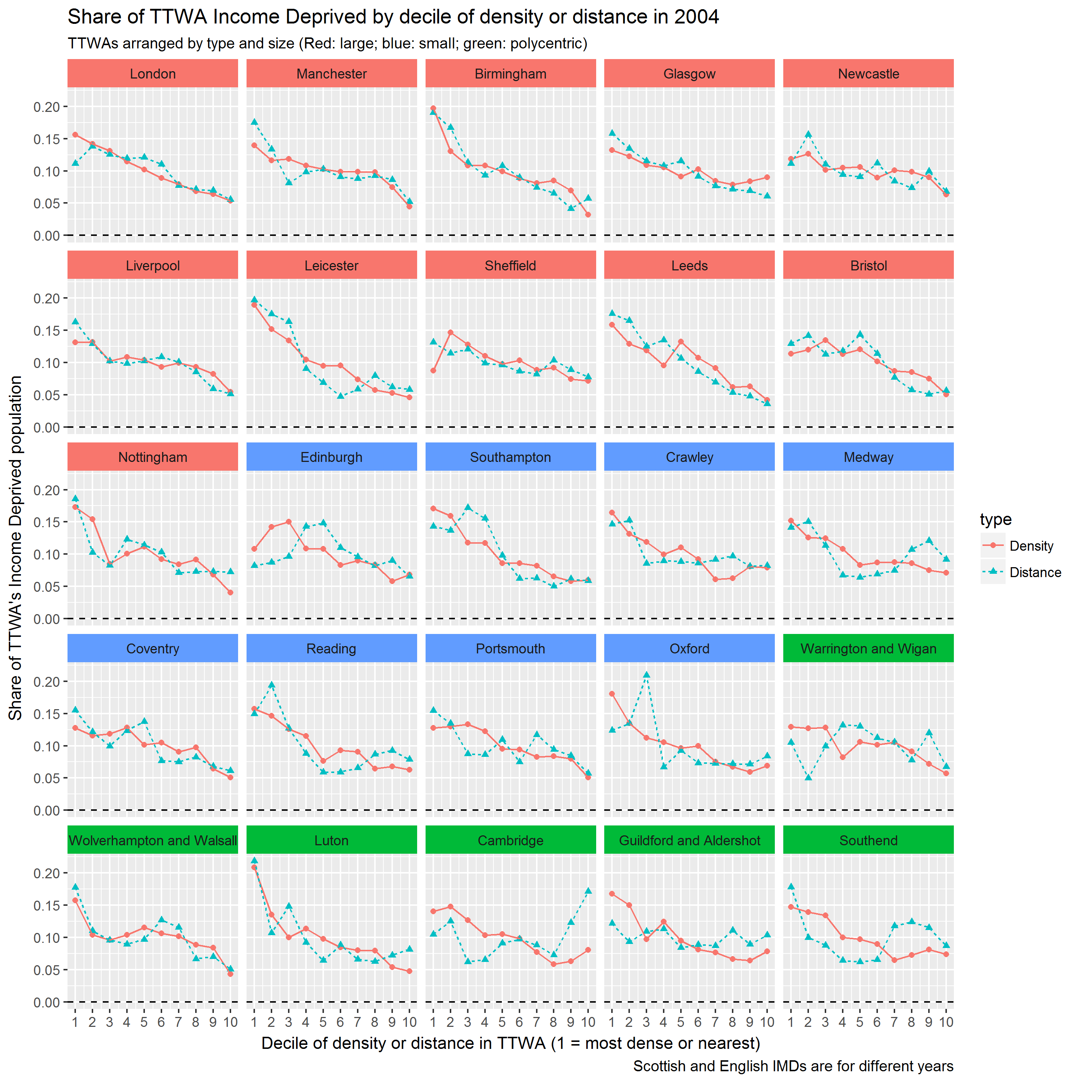

Source: Data from EIMD and SIMD. Equal population deciles based data for 2004. Decile 1 is most dense or closest to city centre. TTWAs ordered by size within type: red – larger; blue – smaller monocentric; green – smaller polycentric.

#### Figure 2: Change in RCI versus change in RDI – 2004 to 2015/16

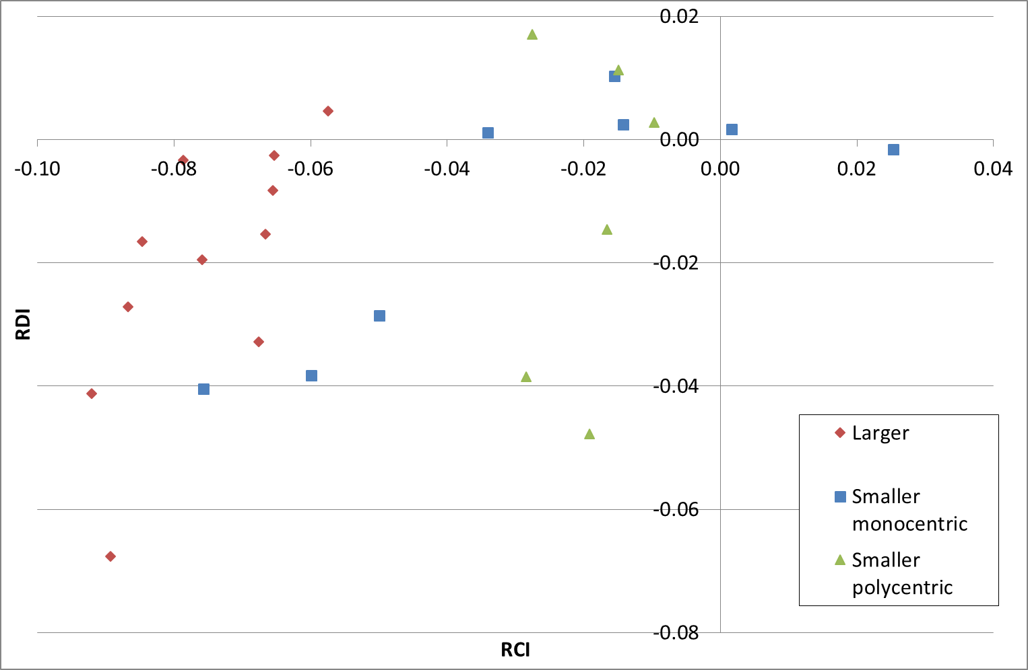

Source: Data from EIMD and SIMD.

#### Figure 3: Change in share of poor and non-poor by distance from city centre – 2004-2015/16

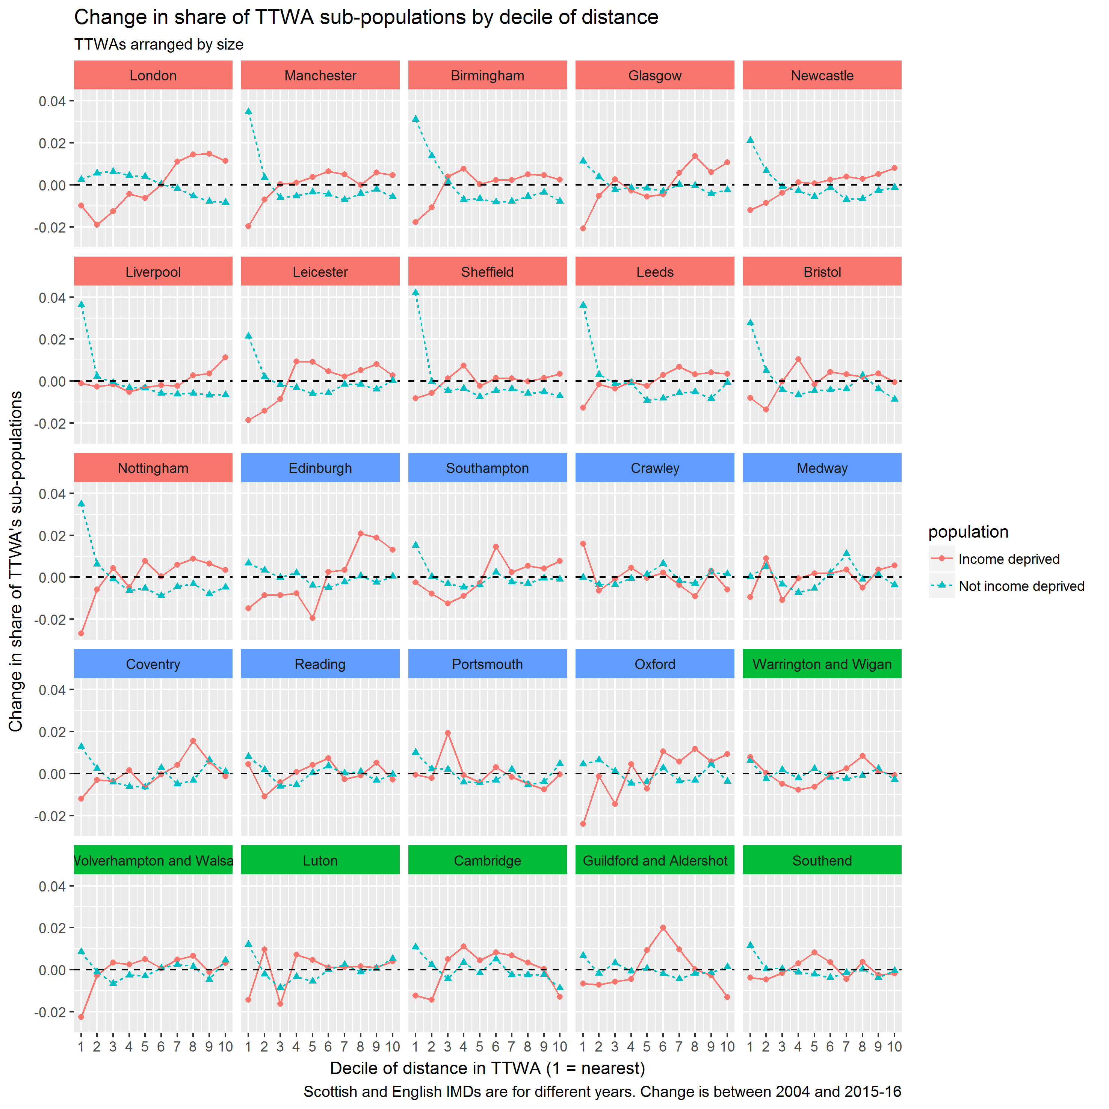

Source: Data from EIMD and SIMD. Equal population deciles based data for 2004. Decile 1 is closest to city centre.

#### Figure 4: Change in share of poor and non-poor by density – 2004-2015/16

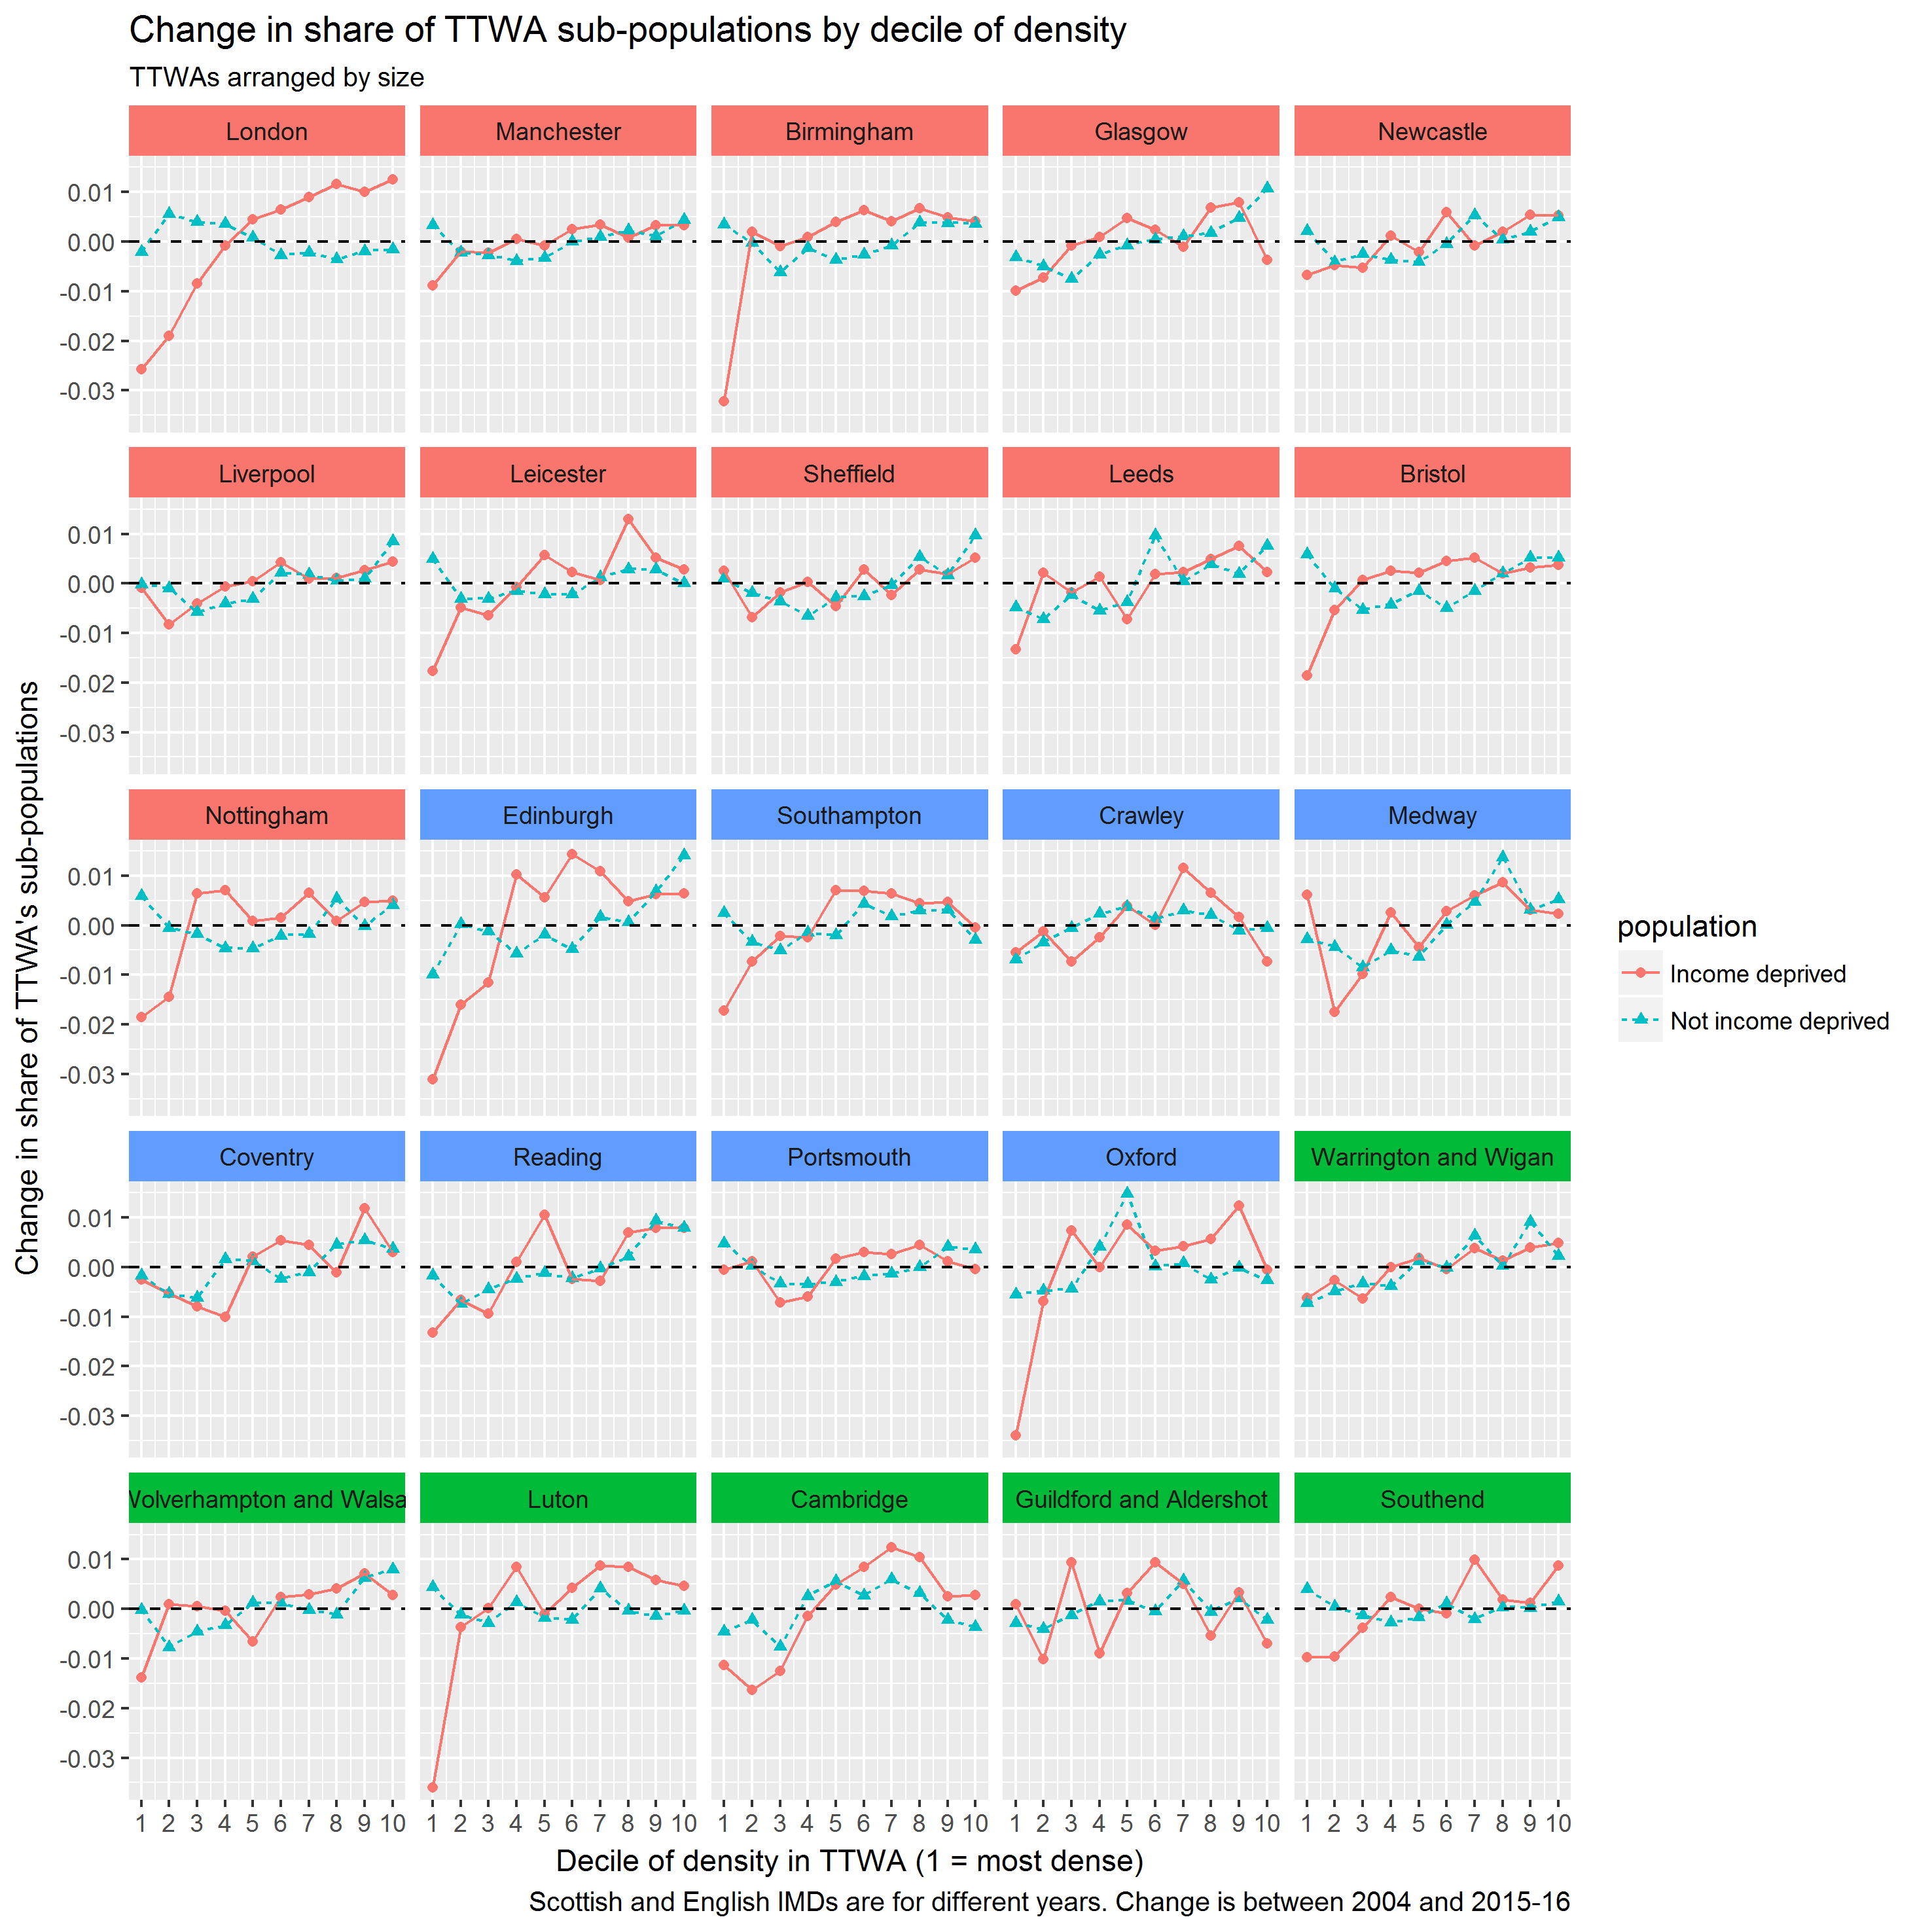

Source: Data from EIMD and SIMD. Equal population deciles based on data for 2004. Decile 1 is most dense.

1. This was done on the basis of the distribution of unit postcodes, using a lookup file kindly provided by Paul Norman, Leeds University.
2. All code used to perform the analyses are freely available from the following web address: <https://github.com/JonMinton/decentralisation_simd_dz2011.git>
3. We make one change to the list, merging the London TTWA with a new TTWA first identified in 2016, covering Slough & Heathrow. This area to the west of London centres on the major employment centre formed around the airport and its related industries. However, it is continuous with the western suburbs of London and, while commuting flows may be sufficient to reach the threshold for self-containment, it clearly still forms part of the London housing market.